# Computer Networks Experiment-1

# Paladugu Reshvanth

# RA1911030010099

## Study of header files with respect to socket programming

Q1)

Program to include header files and show their working

Code:

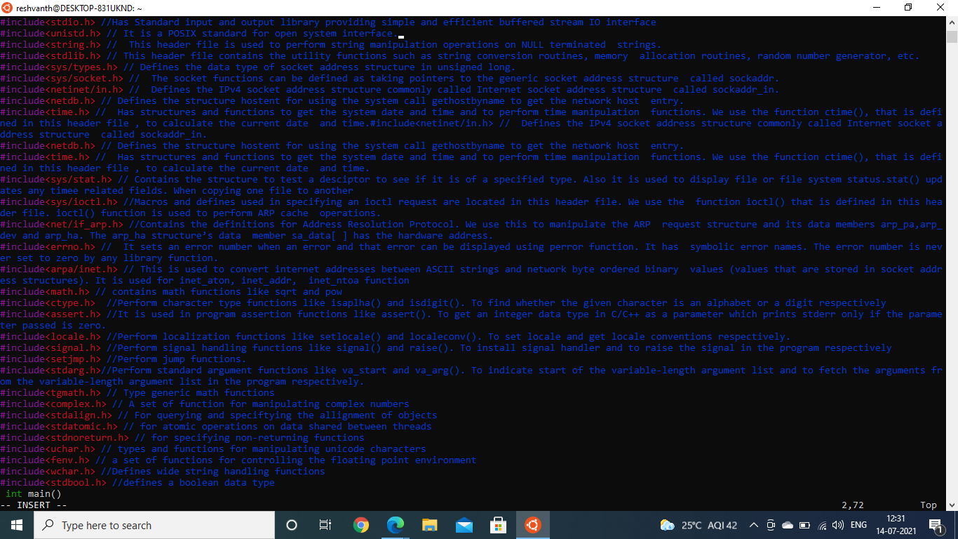

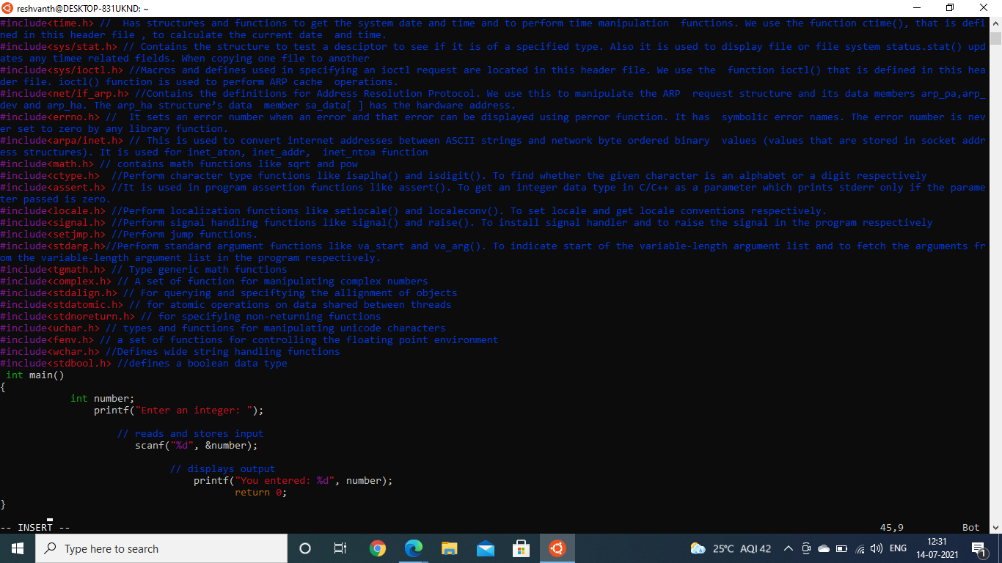

Output:

